

**BinaryBucks - A Comprehensive Banking System**

by:

Nawang Dorjee (2241234)

Raghaw Panpaliya (2241240)

Under the guidance of

Dr. Ramkumar S

A Project report submitted in partial fulfillment of the requirements for the award of degree of Bachelor of Computer Applications of CHRIST (Deemed to be University) April - 2024



CERTIFICATE

*This is to certify that the report titled* ***BinaryBucks*** *is a bona fide record of work done by* ***Nawang Dorjee (2241234)*** *of CHRIST (Deemed to be University), Bengaluru, in partial fulfillment of the requirements of IV Semester BCA during the year 2023-24.*

**Head of the Department Project Guide**

Valued-by:

Name:

Register Number:

Examination Centre: CHRIST (Deemed to be University)

Date of Exam:

**ACKNOWLEDGEMENT**

First of all, I thank the Lord almighty for his immense grace and blessings showered on me at every stage of this work.

I profoundly thank Dr. Fr Benny Thomas, Director, and Dr. Fr Biju K Chacko, Associate Director, CHRIST (Deemed to be University), Bangalore, for providing me the opportunity to be a part of the institution.

I am greatly indebted to the Head of the Department of Computer Science, Dr. Vinay M

CHRIST (Deemed to be University) for providing the opportunity to take up this project as part of my curriculum.

I am greatly indebted to our DBMS Project Coordinator, Dr. Kokilavani T, for

providing the opportunity to take up this project and for helping with her valuable

suggestions.

I am deeply indebted to our project guide Dr Ramkumar S for his assistance and valuable

suggestions as a guide. Their critical suggestions helped us to improve the project work.

I express my sincere thanks to all Faculties of the Department of Computer Science, CHRIST (Deemed to be University), for their valuable suggestions during the course of this project.

Acknowledging the efforts of everyone, their chivalrous help in the course of the project

preparation and their willingness to corroborate with the work, their magnanimity through lucid technical details lead to the successful completion of my project.

I would like to express my sincere thanks to all my friends, colleagues, parents and all those who have directly or indirectly assisted me during this work.

**Abstract**

**PURPOSE:**

BinaryBucks aims to develop a secure and user-friendly online Banking System Website to facilitate efficient and secure banking transactions. Scope: The project scope encompasses the creation of a comprehensive platform, utilizing a robust Database Management System (DBMS) for storing, managing, and retrieving financial information. The website offers features for account holders and administrators, enhancing the overall banking experience.

**OUTCOMES:**

The major outcomes include a secure user authentication system, role-based access control, real-time account management, secure fund transfers, loan and credit management, and an admin dashboard for centralized monitoring. The system is designed to ensure data integrity and security, but limitations such as cybersecurity risks, user learning curve, third-party dependencies, and browser compatibility challenges should be considered.

**TABLE OF CONENTS**

|  |  |  |
| --- | --- | --- |
| 1 | Introduction | 1 |
|  | 1.1 Overview of the system | 1 |
| 2 | System Analysis | 1 |
|  | 2.1 Existing System | 1 |
|  | 2.1.1 Limitations of Existing System | 1 |
|  | 2.2 Proposed System | 2 |
|  | 2.2.1 Benefits of Proposed System | 2 |
|  | 2.3 Functional Requirements | 3 |
| 3 | System Design | 4 |
|  | 3.1 Database Design | 4 |
|  | 3.2 ER Diagram | 5 |
|  | 3.3 Data Flow Diagram | 5 |
|  | 3.4 Use Case Diagram | 6 |
|  | 3.5 User Interface Design | 6 |
| 4 | Implementation | 9 |
|  | 4.1 Source Code | 9 |
|  | 4.2 Screen Shots | 42 |
| 5 | Testing | 49 |
|  | 5.1 Test Strategies | 49 |
|  | 5.1.1 Unit Testing | 49 |
|  | 5.1.2 Functional Testing | 49 |
|  | 5.1.3 Integration Testing | 49 |
|  | 5.2 Test Cases and Reports | 50 |
|  | 5.2.1 Unit Testing | 50 |
|  | 5.2.2 Functional Testing | 51 |
|  | 5.2.3 Integration Testing | 51 |
| 6 | Conclusion | 53 |
| 7 | References | 54 |

**LIST OF FIGURES**

|  |  |  |
| --- | --- | --- |
| Fig no. | Figure Names | Page no |
| 1 | Database Design | 4 |
| 2 | ER Diagram | 5 |
| 3 | Data Flow Diagram | 5 |
| 4 | Use Case Diagram | 6 |
| 5 | User Interface Design | 6 |

**INTRODUCTION**

**1.1 OVERVIEW OF THE SYSTEM**

BinaryBucks is a comprehensive software solution designed to streamline and automate banking operations. The system aims to provide a secure and efficient platform for customers to perform various banking transactions and for bank administrators to manage accounts, transactions, and other related activities.

**SYSTEM ANALYSIS**

**2.1 EXISTING SYSTEM**

The existing banking system may involve manual processes, limited online functionality, and potential inefficiencies in customer service and data management.

**2.1.1 LIMITATION OF EXISTING SYSTEM**

* Lack of a centralized platform for efficient customer interactions.
* Manual handling of transactions leading to potential errors.
* Limited automation, hindering overall operational efficiency.

**2.2 PROPOSED SYSTEM**

The proposed Banking System aims to address the limitations of the existing system by providing a centralized and automated platform for both customers and bank administrators. It will include features such as account management, transaction processing, and enhanced security measures.

**2.2.1 BENEFITS OF PROPOSED SYSTEM**

* Centralized Platform: Provides a unified platform for efficient customer-bank interactions.
* Automation: Streamlines routine processes, reducing the likelihood of errors.
* Enhanced Security: Implements robust security measures to protect customer and financial data.

**2.3 FUNCTIONAL REQUIREMENTS**

**2.3.1 CUSTOMER MODULE**

#### **Account Management**

* User Registration: Customers can create new accounts.
* Account Login: Secure login for registered customers.
* View Account Details: Access to account balance, transaction history, and personal information.

#### **Transactions**

* Fund Transfers: Transfer money between accounts.
* Transaction History: View a detailed history of transactions.

**2.3.2 Administration Module**

#### **User Management**

* Add/Remove Users: Bank administrators can manage customer accounts.
* Access Control: Define user roles and permissions.

#### **Transaction Monitoring**

* Real-time Monitoring: Track and monitor transactions for security and auditing.

**2.4 SOFTWARE REQUIREMENTS**

Frontend:

Development Tools: HTML, CSS, JavaScript for a responsive and interactive user interface.

Backend:

Logic Handling: JavaScript for backend processing.

Databases:

Structured Data Management: MySQL for structured and organized data.

**SYSTEM DESIGN**

**3.1 DATABASE DESIGN**

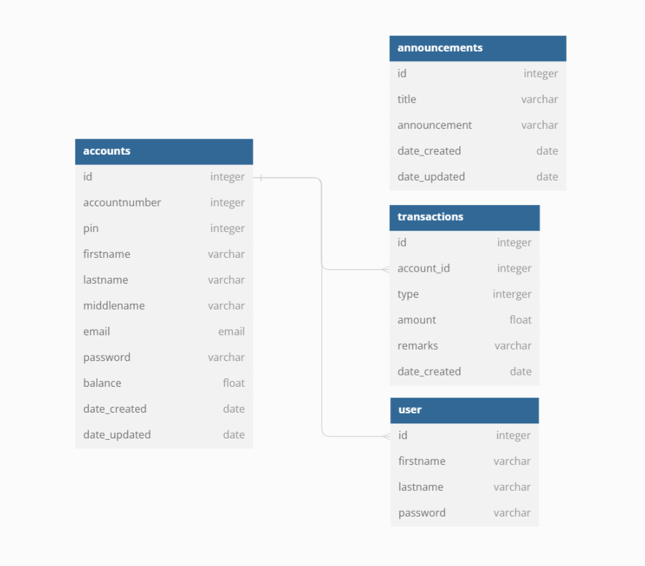

**3.3 DATAFLOW DIAGRAM**

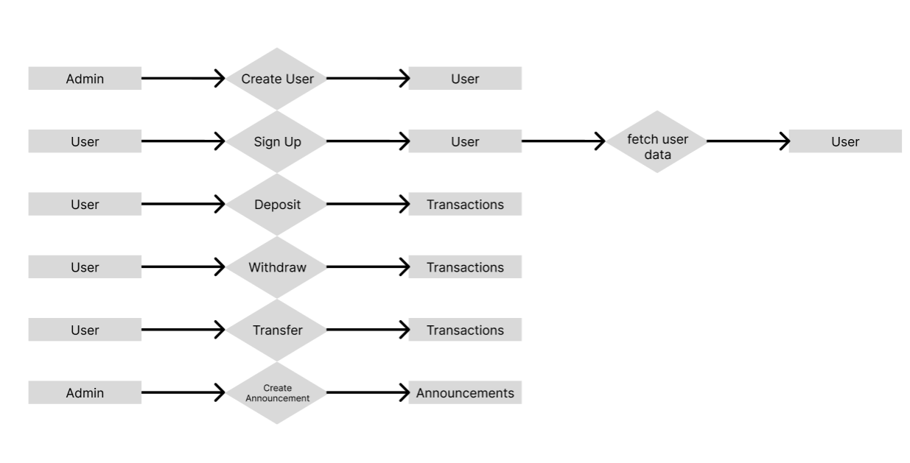

**3.4 USE CASE DIAGRAM**

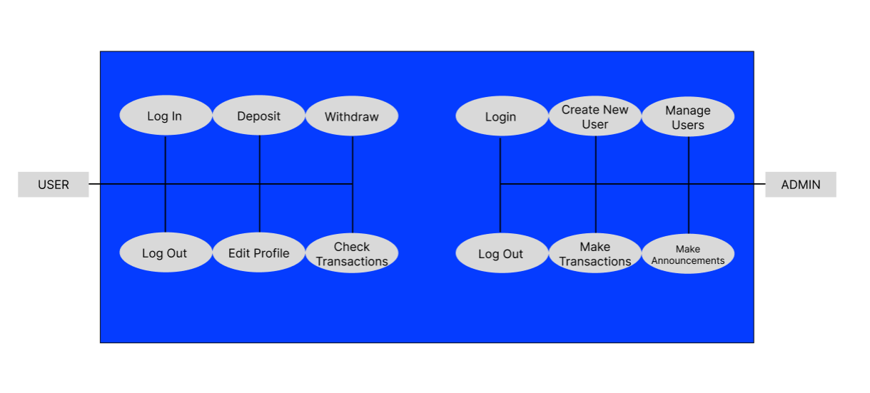

**3.5 USER INTERFACE DESIGN**

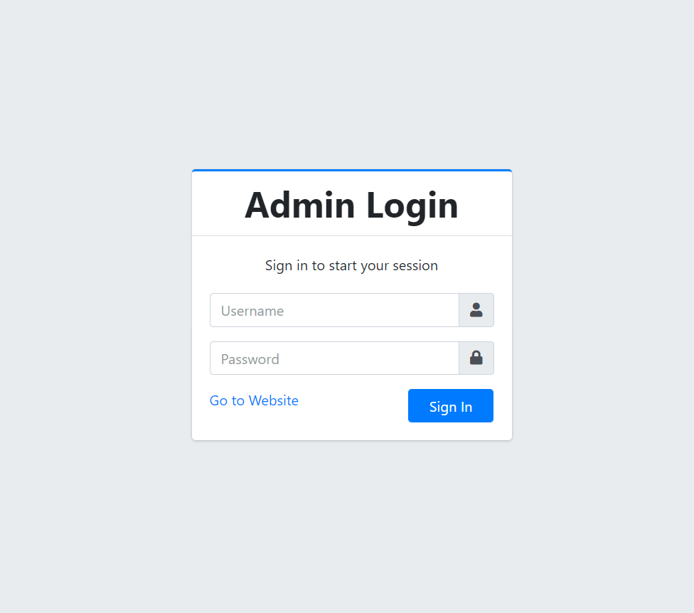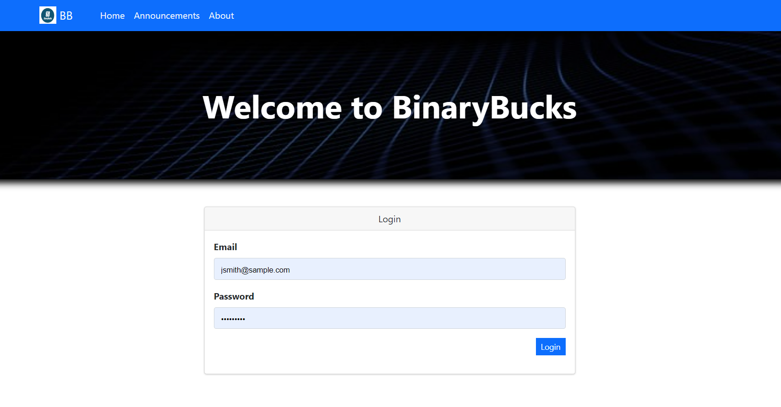

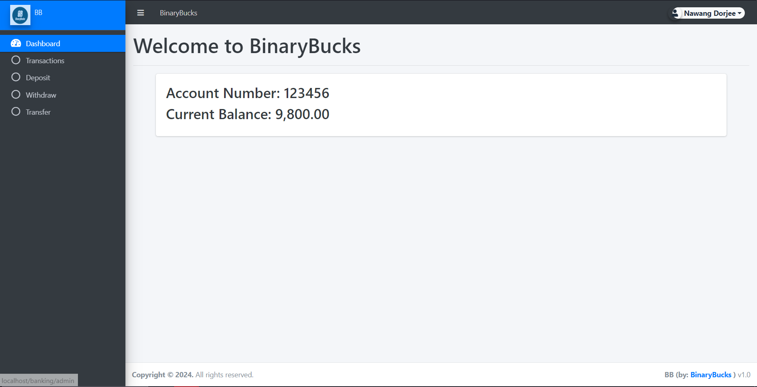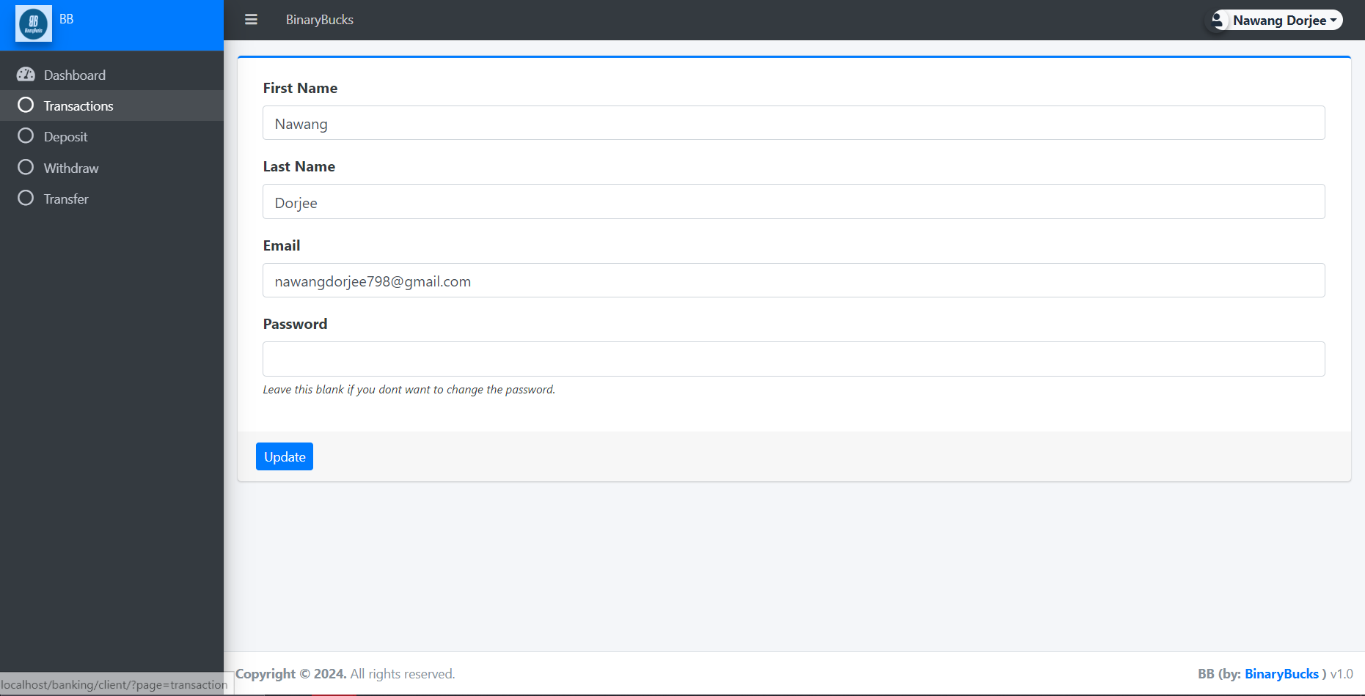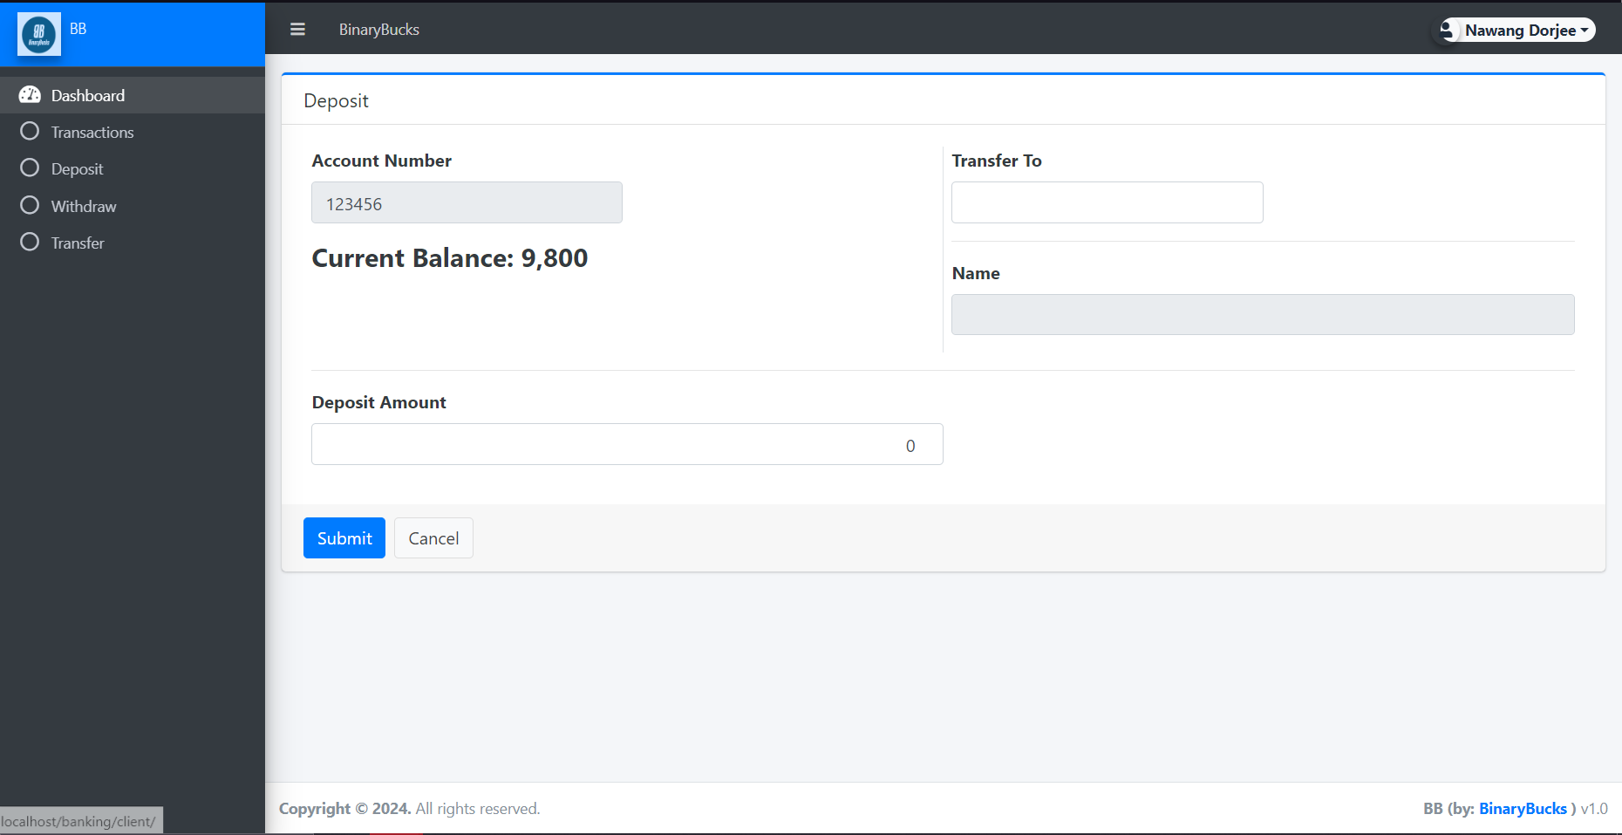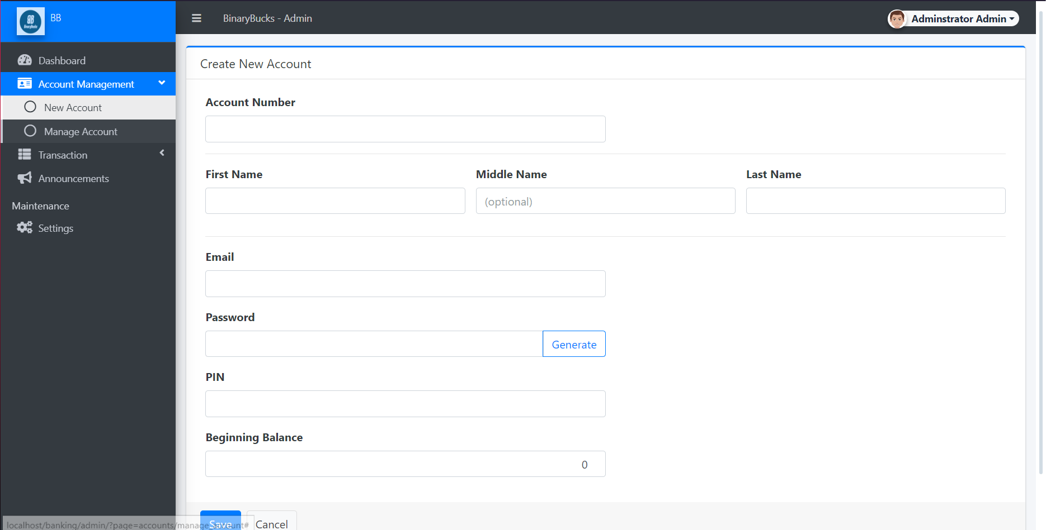

**IMPLEMENTATION**

**4.1 SOURCE CODE**

**Login Page:**

w<!-- Header-->

<header class="bg-dark py-5" id="main-header" >

<div class="container px-4 px-lg-5 my-5">

<div class="text-center text-white">

<h1 class="display-4 fw-bolder">Welcome to <?php echo $_settings->info('name') ?></h1>

</div>

</div>

</header>

<!-- Section-->

<?php

$sched_arr = array();

$max = 0;

?>

<section class="py-5">

<div class="container d-flex justify-content-center">

<div class="card col-md-6 p-0">

<div class="card-header">

<div style="text-align:center;">Login</div>

</div>

<div class="card-body">

<form action="" id="login-client">

<div class="form-group">

<label for="email" class='control-label'>Email</label>

<input type="text" class="form-control" name="email" required>

</div>

<div class="form-group">

<label for="password" class='control-label'>Password</label>

<input type="password" class="form-control" name="password" required>

</div>

<div class="form-group d-flex justify-content-end">

<button class="btn btn-sm btn-primary btn-flat">Login</button>

</div>

</form>

</div>

</div>

</div>

</section>

<script>

</script>

<?php

// require_once('sess_auth.php');

?>

<head>

<meta charset="utf-8">

<meta name="viewport" content="width=device-width, initial-scale=1">

<title><?php echo $_settings->info('title') != false ? $_settings->info('title').' | ' : '' ?><?php echo $_settings->info('name') ?></title>

<link rel="icon" href="<?php echo validate_image($_settings->info('logo')) ?>" />

<!-- Google Font: Source Sans Pro -->

<!-- <link rel="stylesheet" href="https://fonts.googleapis.com/css?family=Source+Sans+Pro:300,400,400i,700&amp;display=fallback"> -->

<!-- Font Awesome -->

<link rel="stylesheet" href="<?php echo base_url ?>plugins/fontawesome-free/css/all.min.css">

<!-- Ionicons -->

<!-- <link rel="stylesheet" href="https://code.ionicframework.com/ionicons/2.0.1/css/ionicons.min.css"> -->

<!-- Tempusdominus Bootstrap 4 -->

<link rel="stylesheet" href="<?php echo base_url ?>plugins/tempusdominus-bootstrap-4/css/tempusdominus-bootstrap-4.min.css">

<!-- DataTables -->

<link rel="stylesheet" href="<?php echo base_url ?>plugins/datatables-bs4/css/dataTables.bootstrap4.min.css">

<link rel="stylesheet" href="<?php echo base_url ?>plugins/datatables-responsive/css/responsive.bootstrap4.min.css">

<link rel="stylesheet" href="<?php echo base_url ?>plugins/datatables-buttons/css/buttons.bootstrap4.min.css">

<!-- Select2 -->

<link rel="stylesheet" href="<?php echo base_url ?>plugins/select2/css/select2.min.css">

<link rel="stylesheet" href="<?php echo base_url ?>plugins/select2-bootstrap4-theme/select2-bootstrap4.min.css">

<!-- iCheck -->

<link rel="stylesheet" href="<?php echo base_url ?>plugins/icheck-bootstrap/icheck-bootstrap.min.css">

<!-- JQVMap -->

<link rel="stylesheet" href="<?php echo base_url ?>plugins/jqvmap/jqvmap.min.css">

<!-- Theme style -->

<link rel="stylesheet" href="<?php echo base_url ?>dist/css/adminlte.css">

<link rel="stylesheet" href="<?php echo base_url ?>dist/css/custom.css">

<link rel="stylesheet" href="<?php echo base_url ?>assets/css/styles.css">

<!-- overlayScrollbars -->

<link rel="stylesheet" href="<?php echo base_url ?>plugins/overlayScrollbars/css/OverlayScrollbars.min.css">

<!-- Daterange picker -->

<link rel="stylesheet" href="<?php echo base_url ?>plugins/daterangepicker/daterangepicker.css">

<!-- summernote -->

<link rel="stylesheet" href="<?php echo base_url ?>plugins/summernote/summernote-bs4.min.css">

<!-- SweetAlert2 -->

<link rel="stylesheet" href="<?php echo base_url ?>plugins/sweetalert2-theme-bootstrap-4/bootstrap-4.min.css">

<style type="text/css">/* Chart.js */

@keyframes chartjs-render-animation{from{opacity:.99}to{opacity:1}}.chartjs-render-monitor{animation:chartjs-render-animation 1ms}.chartjs-size-monitor,.chartjs-size-monitor-expand,.chartjs-size-monitor-shrink{position:absolute;direction:ltr;left:0;top:0;right:0;bottom:0;overflow:hidden;pointer-events:none;visibility:hidden;z-index:-1}.chartjs-size-monitor-expand>div{position:absolute;width:1000000px;height:1000000px;left:0;top:0}.chartjs-size-monitor-shrink>div{position:absolute;width:200%;height:200%;left:0;top:0}

</style>

<!-- fullCalendar -->

<link rel="stylesheet" href="<?php echo base_url ?>plugins/fullcalendar/main.css">

<!-- jQuery -->

<script src="<?php echo base_url ?>plugins/jquery/jquery.min.js"></script>

<!-- jQuery UI 1.11.4 -->

<script src="<?php echo base_url ?>plugins/jquery-ui/jquery-ui.min.js"></script>

<!-- SweetAlert2 -->

<script src="<?php echo base_url ?>plugins/sweetalert2/sweetalert2.min.js"></script>

<!-- Toastr -->

<script src="<?php echo base_url ?>plugins/toastr/toastr.min.js"></script>

<script>

var _base_url_ = '<?php echo base_url ?>';

</script>

<!-- fullCalendar 2.2.5 -->

<script src="<?php echo base_url ?>plugins/moment/moment.min.js"></script>

<script src="<?php echo base_url ?>plugins/fullcalendar/main.js"></script>

<script src="<?php echo base_url ?>dist/js/script.js"></script>

<script src="<?php echo base_url ?>assets/js/scripts.js"></script>

<style>

#main-header{

position:relative;

background: rgb(0,0,0)!important;

background: radial-gradient(circle, rgba(0,0,0,0.48503151260504207) 22%, rgba(0,0,0,0.39539565826330536) 49%, rgba(0,212,255,0) 100%)!important;

}

#main-header:before{

content:"";

position:absolute;

top:0;

left:0;

width:100%;

height:100%;

background-image:url(<?php echo base_url.$_settings->info('cover') ?>);

background-repeat: no-repeat;

background-size: cover;

filter: drop-shadow(0px 7px 6px black);

z-index:-1;

}

</style>

</head>

**Announcements:**

<?php

require_once('config.php');

if(isset($_GET['id']) && $_GET['id'] > 0){

$qry = $conn->query("SELECT * from `announcements` where id = '{$_GET['id']}' ");

if($qry->num_rows > 0){

foreach($qry->fetch_assoc() as $k => $v){

$$k=$v;

}

}

}

?>

<style>

#uni_modal .modal-content>.modal-footer{

display:none;

}

#uni_modal .modal-body{

padding:0 !important;

}

</style>

<div class="container-fluid p-2">

<div><?php echo stripslashes(html_entity_decode($announcement)) ?></div>

<div class="d-flex w-100 justify-content-end">

<small class="mb-3"><?php echo date("M d,Y h:i A",strtotime($date_created)) ?></small>

</div>

</div>

<div class="modal-footer p-0">

<button type="button" class="btn btn-default" data-dismiss="modal">Close</button>

</div>

**Deposit:**

<?php

if(isset($_GET['id']) && $_GET['id'] > 0){

$qry = $conn->query("SELECT * from `accounts` where id = '{$_GET['id']}' ");

if($qry->num_rows > 0){

foreach($qry->fetch_assoc() as $k => $v){

$$k=$v;

}

}

}

?>

<?php if($_settings->chk_flashdata('success')): ?>

<script>

alert_toast("<?php echo $_settings->flashdata('success') ?>",'success')

</script>

<?php endif;?>

<div class="card card-outline card-primary">

<div class="card-header">

<h3 class="card-title">Deposit</h3>

</div>

<div class="card-body">

<div class="container-fluid">

<form id="account-form">

<div class="form-group">

<label class="control-label">Account Number</label>

<input type="text" class="form-control col-sm-6" name="account_number" value="<?php echo $_settings->userdata('account_number') ?>" readonly autocomplete="off">

<input type="hidden" value="<?php echo $_settings->userdata('id') ?>" name="account_id" >

<input type="hidden" value="<?php echo $_settings->userdata('balance') ?>" name="current" >

</div>

<div class="form-group">

<h4><b>Current Balance: <?php echo number_format($_settings->userdata('balance',2)) ?></b></h4>

</div>

<hr>

<div class="form-group">

<label class="control-label">Deposit Amount</label>

<input type="number" step='any' min = "0" class="form-control col-sm-6 text-right" name="balance" value="0" required>

</div>

</form>

</div>

</div>

<div class="card-footer">

<div class="d-flex w-100">

<button form="account-form" class="btn btn-primary mr-2">Submit</button>

<a href="./?page=transaction" class="btn btn-default">Cancel</a>

</div>

</div>

</div>

<script>

$(function(){

$('#account-form').submit(function(e){

e.preventDefault()

start_loader()

if($('.err_msg').length > 0)

$('.err_msg').remove()

$.ajax({

url:_base_url_+'classes/Master.php?f=deposit',

method:'POST',

data:$(this).serialize(),

dataType:'json',

error:err=>{

console.log(err)

alert_toast("An error occured","error")

end_loader()

},

success:function(resp){

if(resp.status == 'success'){

location.reload();

}else if(!!resp.msg){

var msg = $('<div class="err_msg"><div class="alert alert-danger">'+resp.msg+'</div></div>')

$('#account-form').prepend(msg)

msg.show('slow')

}else{

alert_toast('An error occured',"error")

console.log(resp)

}

end_loader()

}

})

})

})

</script>

**Withdraw:**

<?php

if(isset($_GET['id']) && $_GET['id'] > 0){

$qry = $conn->query("SELECT * from `accounts` where id = '{$_GET['id']}' ");

if($qry->num_rows > 0){

foreach($qry->fetch_assoc() as $k => $v){

$$k=$v;

}

}

}

?>

<?php if($_settings->chk_flashdata('success')): ?>

<script>

alert_toast("<?php echo $_settings->flashdata('success') ?>",'success')

</script>

<?php endif;?>

<div class="card card-outline card-primary">

<div class="card-header">

<h3 class="card-title">Widthdraw</h3>

</div>

<div class="card-body">

<div class="container-fluid">

<form id="account-form">

<div class="form-group">

<label class="control-label">Account Number</label>

<input type="text" class="form-control col-sm-6" name="account_number" value="<?php echo $_settings->userdata('account_number') ?>" readonly autocomplete="off">

<input type="hidden" value="<?php echo $_settings->userdata('id') ?>" name="account_id" >

<input type="hidden" value="<?php echo $_settings->userdata('balance') ?>" name="current" >

</div>

<div class="form-group">

<h4><b>Current Balance: <?php echo number_format($_settings->userdata('balance',2)) ?></b></h4>

</div>

<hr>

<div class="form-group">

<label class="control-label">Deposit Amount</label>

<input type="number" step='any' min = "0" class="form-control col-sm-6 text-right" name="balance" value="0" required>

</div>

</form>

</div>

</div>

<div class="card-footer">

<div class="d-flex w-100">

<button form="account-form" class="btn btn-primary mr-2">Submit</button>

<a href="./?page=transaction" class="btn btn-default">Cancel</a>

</div>

</div>

</div>

<script>

$(function(){

$('#account-form').submit(function(e){

e.preventDefault()

if(parseFloat($('[name="current"]').val()) < parseFloat($('[name="balance"]').val())){

alert_toast("Amount is greater than your current balance",'warning')

return false;

}

start_loader()

if($('.err_msg').length > 0)

$('.err_msg').remove()

$.ajax({

url:_base_url_+'classes/Master.php?f=withdraw',

method:'POST',

data:$(this).serialize(),

dataType:'json',

error:err=>{

console.log(err)

alert_toast("An error occured","error")

end_loader()

},

success:function(resp){

if(resp.status == 'success'){

location.reload();

}else if(!!resp.msg){

var msg = $('<div class="err_msg"><div class="alert alert-danger">'+resp.msg+'</div></div>')

$('#account-form').prepend(msg)

msg.show('slow')

}else{

alert_toast('An error occured',"error")

console.log(resp)

}

end_loader()

}

})

})

})

</script>

**Transfer:**

<?php

if(isset($_GET['id']) && $_GET['id'] > 0){

$qry = $conn->query("SELECT * from `accounts` where id = '{$_GET['id']}' ");

if($qry->num_rows > 0){

foreach($qry->fetch_assoc() as $k => $v){

$$k=$v;

}

}

}

?>

<?php if($_settings->chk_flashdata('success')): ?>

<script>

alert_toast("<?php echo $_settings->flashdata('success') ?>",'success')

</script>

<?php endif;?>

<div class="card card-outline card-primary">

<div class="card-header">

<h3 class="card-title">Deposit</h3>

</div>

<div class="card-body">

<div class="container-fluid">

<form id="account-form">

<input type="hidden" name="id" value='<?php echo isset($id)? $id : '' ?>'>

<div class="row">

<div class="col-md-6 border-right">

<div class="form-group">

<label class="control-label">Account Number</label>

<input type="text" class="form-control col-sm-6" name="account_number" value="<?php echo $_settings->userdata('account_number') ?>" readonly autocomplete="off">

<input type="hidden" value="<?php echo $_settings->userdata('id') ?>" name="account_id" >

<input type="hidden" value="<?php echo $_settings->userdata('balance') ?>" name="current" >

</div>

<div class="form-group">

<h4><b>Current Balance: <?php echo number_format($_settings->userdata('balance',2)) ?></b></h4>

</div>

</div>

<div class="col-md-6">

<div class="form-group">

<label class="control-label">Transfer To</label>

<input type="text" class="form-control col-sm-6" name="transfer_number" value="<?php echo isset($transfer_number)? $transfer_number : '' ?>" required autocomplete="off">

</div>

<hr>

<div class="form-group">

<input type="hidden" name="transfer_id" value="">

<label class="control-label">Name</label>

<input type="text" class="form-control" id="transfer_name" name="transfer_name" readonly>

</div>

</div>

</div>

<hr>

<div class="form-group">

<label class="control-label">Deposit Amount</label>

<input type="number" step='any' min = "0" class="form-control col-sm-6 text-right" name="balance" value="0" required>

</div>

</form>

</div>

</div>

<div class="card-footer">

<div class="d-flex w-100">

<button form="account-form" class="btn btn-primary mr-2">Submit</button>

<a href="./?page=transaction" class="btn btn-default">Cancel</a>

</div>

</div>

</div>

<script>

$(function(){

$('#generate_pass').click(function(){

var randomstring = Math.random().toString(36).slice(-8);

$('[name="generated_password"]').val(randomstring)

})

$('[name="account_number"]').on('input',function(){

if($('._checks').length > 0)

$('._checks').remove()

$('[name="account_id"]').val('')

$('#name').val('')

$('#balance').val('')

$(this).removeClass('border-danger')

$(this).removeClass('border-success')

if($(this).val() == '')

return false;

$('button[form="account-form"]').attr('disabled',true)

var checks = $('<small class="_checks">')

checks.text("Checking availablity")

$('[name="account_number"]').after(checks)

$.ajax({

url:_base_url_+'classes/Master.php?f=get_account',

method:'POST',

data:{account_number: $(this).val()},

dataType:'json',

error:err=>{

console.log(err)

alert_toast("An error occured","error")

end_loader()

},

success:function(resp){

if(resp.status == 'success'){

checks.hide('slow').remove()

$('[name="account_number"]').addClass('border-success')

$('button[form="account-form"]').attr('disabled',false)

$('[name="account_id"]').val(resp.data.id)

$('#name').val(resp.data.name)

$('#balance').val(resp.data.balance)

}else if(resp.status == 'not_exist'){

checks.addClass('text-danger')

checks.text('Account doesn\'t exist')

$('[name="account_number"]').addClass('border-danger')

$('button[form="account-form"]').attr('disabled',true)

}else{

alert_toast('An error occured',"error")

$('[name="account_number"]').addClass('border-danger')

console.log(resp)

}

end_loader()

}

})

})

$('[name="transfer_number"]').on('input',function(){

if($('._checks2').length > 0)

$('._checks2').remove()

$('[name="transfer_id"]').val('')

$('#transfer_name').val('')

$(this).removeClass('border-danger')

$(this).removeClass('border-success')

if($(this).val() == '')

return false;

$('button[form="account-form"]').attr('disabled',true)

var checks = $('<small class="_checks2">')

checks.text("Checking availablity")

$('[name="transfer_number"]').after(checks)

$.ajax({

url:_base_url_+'classes/Master.php?f=get_account',

method:'POST',

data:{account_number: $(this).val()},

dataType:'json',

error:err=>{

console.log(err)

alert_toast("An error occured","error")

end_loader()

},

success:function(resp){

if(resp.status == 'success'){

checks.hide('slow').remove()

$('[name="transfer_number"]').addClass('border-success')

$('button[form="account-form"]').attr('disabled',false)

$('[name="transfer_id"]').val(resp.data.id)

$('#transfer_name').val(resp.data.name)

}else if(resp.status == 'not_exist'){

checks.addClass('text-danger')

checks.text('Account doesn\'t exist')

$('[name="transfer_number"]').addClass('border-danger')

$('button[form="account-form"]').attr('disabled',true)

}else{

alert_toast('An error occured',"error")

$('[name="transfer_number"]').addClass('border-danger')

console.log(resp)

}

end_loader()

}

})

})

$('#account-form').submit(function(e){

e.preventDefault()

if(parseFloat($('[name="current"]').val()) < parseFloat($('[name="balance"]').val())){

alert_toast("Amount is greater than client's balance",'warning')

return false;

}

start_loader()

if($('.err_msg').length > 0)

$('.err_msg').remove()

$.ajax({

url:_base_url_+'classes/Master.php?f=transfer',

method:'POST',

data:$(this).serialize(),

dataType:'json',

error:err=>{

console.log(err)

alert_toast("An error occured","error")

end_loader()

},

success:function(resp){

if(resp.status == 'success'){

location.reload();

}else if(!!resp.msg){

var msg = $('<div class="err_msg"><div class="alert alert-danger">'+resp.msg+'</div></div>')

$('#account-form').prepend(msg)

msg.show('slow')

}else{

alert_toast('An error occured',"error")

console.log(resp)

}

end_loader()

}

})

})

})

</script>

**System Info:**

<?php if($_settings->chk_flashdata('success')): ?>

<script>

alert_toast("<?php echo $_settings->flashdata('success') ?>",'success')

</script>

<?php endif;?>

<style>

img#cimg{

height: 15vh;

width: 15vh;

object-fit: cover;

border-radius: 100% 100%;

}

img#cimg2{

height: 50vh;

width: 100%;

object-fit: contain;

/* border-radius: 100% 100%; */

}

</style>

<div class="col-lg-12">

<div class="card card-outline card-primary">

<div class="card-header">

<h5 class="card-title">System Information</h5>

<!-- <div class="card-tools">

<a class="btn btn-block btn-sm btn-default btn-flat border-primary new_department" href="javascript:void(0)"><i class="fa fa-plus"></i> Add New</a>

</div> -->

</div>

<div class="card-body">

<form action="" id="system-frm">

<div id="msg" class="form-group"></div>

<div class="form-group">

<label for="name" class="control-label">System Name</label>

<input type="text" class="form-control form-control-sm" name="name" id="name" value="<?php echo $_settings->info('name') ?>">

</div>

<div class="form-group">

<label for="short_name" class="control-label">System Short Name</label>

<input type="text" class="form-control form-control-sm" name="short_name" id="short_name" value="<?php echo $_settings->info('short_name') ?>">

</div>

<div class="form-group">

<label for="" class="control-label">About Us</label>

<textarea name="about_us" id="" cols="30" rows="2" class="form-control summernote"><?php echo is_file(base_app.'about.html') ? file_get_contents(base_app.'about.html') : "" ?></textarea>

</div>

<!-- <div class="form-group">

<label for="" class="control-label">Privacy Policy</label>

<textarea name="privacy_policy" id="" cols="30" rows="2" class="form-control summernote"><?php echo is_file(base_app.'privacy_policy.html') ? file_get_contents(base_app.'privacy_policy.html') : "" ?></textarea>

</div> -->

<div class="form-group">

<label for="" class="control-label">System Logo</label>

<div class="custom-file">

<input type="file" class="custom-file-input rounded-circle" id="customFile" name="img" onchange="displayImg(this,$(this))">

<label class="custom-file-label" for="customFile">Choose file</label>

</div>

</div>

<div class="form-group d-flex justify-content-center">

<img src="<?php echo validate_image($_settings->info('logo')) ?>" alt="" id="cimg" class="img-fluid img-thumbnail">

</div>

<div class="form-group">

<label for="" class="control-label">Website Cover</label>

<div class="custom-file">

<input type="file" class="custom-file-input rounded-circle" id="customFile" name="cover" onchange="displayImg2(this,$(this))">

<label class="custom-file-label" for="customFile">Choose file</label>

</div>

</div>

<div class="form-group d-flex justify-content-center">

<img src="<?php echo validate_image($_settings->info('cover')) ?>" alt="" id="cimg2" class="img-fluid img-thumbnail">

</div>

</form>

</div>

<div class="card-footer">

<div class="col-md-12">

<div class="row">

<button class="btn btn-sm btn-primary" form="system-frm">Update</button>

</div>

</div>

</div>

</div>

</div>

<script>

function displayImg(input,_this) {

if (input.files && input.files[0]) {

var reader = new FileReader();

reader.onload = function (e) {

$('#cimg').attr('src', e.target.result);

_this.siblings('.custom-file-label').html(input.files[0].name)

}

reader.readAsDataURL(input.files[0]);

}

}

function displayImg2(input,_this) {

if (input.files && input.files[0]) {

var reader = new FileReader();

reader.onload = function (e) {

_this.siblings('.custom-file-label').html(input.files[0].name)

$('#cimg2').attr('src', e.target.result);

}

reader.readAsDataURL(input.files[0]);

}

}

function displayImg3(input,_this) {

if (input.files && input.files[0]) {

var reader = new FileReader();

reader.onload = function (e) {

_this.siblings('.custom-file-label').html(input.files[0].name)

$('#cimg3').attr('src', e.target.result);

}

reader.readAsDataURL(input.files[0]);

}

}

$(document).ready(function(){

$('.summernote').summernote({

height: 200,

toolbar: [

[ 'style', [ 'style' ] ],

[ 'font', [ 'bold', 'italic', 'underline', 'strikethrough', 'superscript', 'subscript', 'clear'] ],

[ 'fontname', [ 'fontname' ] ],

[ 'fontsize', [ 'fontsize' ] ],

[ 'color', [ 'color' ] ],

[ 'para', [ 'ol', 'ul', 'paragraph', 'height' ] ],

[ 'table', [ 'table' ] ],

[ 'view', [ 'undo', 'redo', 'fullscreen', 'codeview', 'help' ] ]

]

})

})

</script>

**Header:**

<?php

require_once('sess_auth.php');

?>

<head>

<meta charset="utf-8">

<meta name="viewport" content="width=device-width, initial-scale=1">

<title><?php echo $_settings->info('title') != false ? $_settings->info('title').' | ' : '' ?><?php echo $_settings->info('name') ?></title>

<link rel="icon" href="<?php echo validate_image($_settings->info('logo')) ?>" />

<!-- Google Font: Source Sans Pro -->

<!-- <link rel="stylesheet" href="https://fonts.googleapis.com/css?family=Source+Sans+Pro:300,400,400i,700&amp;display=fallback"> -->

<!-- Font Awesome -->

<link rel="stylesheet" href="<?php echo base_url ?>plugins/fontawesome-free/css/all.min.css">

<!-- Ionicons -->

<!-- <link rel="stylesheet" href="https://code.ionicframework.com/ionicons/2.0.1/css/ionicons.min.css"> -->

<!-- Tempusdominus Bootstrap 4 -->

<link rel="stylesheet" href="<?php echo base_url ?>plugins/tempusdominus-bootstrap-4/css/tempusdominus-bootstrap-4.min.css">

<!-- DataTables -->

<link rel="stylesheet" href="<?php echo base_url ?>plugins/datatables-bs4/css/dataTables.bootstrap4.min.css">

<link rel="stylesheet" href="<?php echo base_url ?>plugins/datatables-responsive/css/responsive.bootstrap4.min.css">

<link rel="stylesheet" href="<?php echo base_url ?>plugins/datatables-buttons/css/buttons.bootstrap4.min.css">

<link rel="stylesheet" href="<?php echo base_url ?>plugins/datatables-select/css/select.bootstrap4.min.css">

<!-- Select2 -->

<link rel="stylesheet" href="<?php echo base_url ?>plugins/select2/css/select2.min.css">

<link rel="stylesheet" href="<?php echo base_url ?>plugins/select2-bootstrap4-theme/select2-bootstrap4.min.css">

<!-- iCheck -->

<link rel="stylesheet" href="<?php echo base_url ?>plugins/icheck-bootstrap/icheck-bootstrap.min.css">

<!-- JQVMap -->

<link rel="stylesheet" href="<?php echo base_url ?>plugins/jqvmap/jqvmap.min.css">

<!-- Theme style -->

<link rel="stylesheet" href="<?php echo base_url ?>dist/css/adminlte.css">

<link rel="stylesheet" href="<?php echo base_url ?>dist/css/custom.css">

<!-- overlayScrollbars -->

<link rel="stylesheet" href="<?php echo base_url ?>plugins/overlayScrollbars/css/OverlayScrollbars.min.css">

<!-- Daterange picker -->

<link rel="stylesheet" href="<?php echo base_url ?>plugins/daterangepicker/daterangepicker.css">

<!-- summernote -->

<link rel="stylesheet" href="<?php echo base_url ?>plugins/summernote/summernote-bs4.min.css">

<!-- SweetAlert2 -->

<link rel="stylesheet" href="<?php echo base_url ?>plugins/sweetalert2-theme-bootstrap-4/bootstrap-4.min.css">

<!-- fullCalendar -->

<link rel="stylesheet" href="<?php echo base_url ?>plugins/fullcalendar/main.css">

<style type="text/css">/* Chart.js */

@keyframes chartjs-render-animation{from{opacity:.99}to{opacity:1}}.chartjs-render-monitor{animation:chartjs-render-animation 1ms}.chartjs-size-monitor,.chartjs-size-monitor-expand,.chartjs-size-monitor-shrink{position:absolute;direction:ltr;left:0;top:0;right:0;bottom:0;overflow:hidden;pointer-events:none;visibility:hidden;z-index:-1}.chartjs-size-monitor-expand>div{position:absolute;width:1000000px;height:1000000px;left:0;top:0}.chartjs-size-monitor-shrink>div{position:absolute;width:200%;height:200%;left:0;top:0}

</style>

<!-- jQuery -->

<script src="<?php echo base_url ?>plugins/jquery/jquery.min.js"></script>

<!-- jQuery UI 1.11.4 -->

<script src="<?php echo base_url ?>plugins/jquery-ui/jquery-ui.min.js"></script>

<!-- SweetAlert2 -->

<script src="<?php echo base_url ?>plugins/sweetalert2/sweetalert2.min.js"></script>

<!-- Toastr -->

<script src="<?php echo base_url ?>plugins/toastr/toastr.min.js"></script>

<!-- fullCalendar 2.2.5 -->

<script src="<?php echo base_url ?>plugins/moment/moment.min.js"></script>

<script src="<?php echo base_url ?>plugins/fullcalendar/main.js"></script>

<script>

var _base_url_ = '<?php echo base_url ?>';

</script>

<script src="<?php echo base_url ?>dist/js/script.js"></script>

</head>

**Footer:**

<script>

$(document).ready(function(){

window.viewer_modal = function($src = ''){

start_loader()

var t = $src.split('.')

t = t[1]

if(t =='mp4'){

var view = $("<video src='"+$src+"' controls autoplay></video>")

}else{

var view = $("<img src='"+$src+"' />")

}

$('#viewer_modal .modal-content video,#viewer_modal .modal-content img').remove()

$('#viewer_modal .modal-content').append(view)

$('#viewer_modal').modal({

show:true,

backdrop:'static',

keyboard:false,

focus:true

})

end_loader()

}

window.uni_modal = function($title = '' , $url='',$size=""){

start_loader()

$.ajax({

url:$url,

error:err=>{

console.log()

alert("An error occured")

},

success:function(resp){

if(resp){

$('#uni_modal .modal-title').html($title)

$('#uni_modal .modal-body').html(resp)

if($size != ''){

$('#uni_modal .modal-dialog').addClass($size+' modal-dialog-centered')

}else{

$('#uni_modal .modal-dialog').removeAttr("class").addClass("modal-dialog modal-md modal-dialog-centered")

}

$('#uni_modal').modal({

show:true,

backdrop:'static',

keyboard:false,

focus:true

})

end_loader()

}

}

})

}

window._conf = function($msg='',$func='',$params = []){

$('#confirm_modal #confirm').attr('onclick',$func+"("+$params.join(',')+")")

$('#confirm_modal .modal-body').html($msg)

$('#confirm_modal').modal('show')

}

})

</script>

<footer class="main-footer text-sm">

<strong>Copyright © <?php echo date('Y') ?>.

<!-- <a href=""></a> -->

</strong>

All rights reserved.

<div class="float-right d-none d-sm-inline-block">

<b><?php echo $_settings->info('short_name') ?> (by: <a href="#" target="blank">BinaryBucks</a> )</b> v1.0

</div>

</footer>

</div>

<!-- ./wrapper -->

<!-- Resolve conflict in jQuery UI tooltip with Bootstrap tooltip -->

<script>

$.widget.bridge('uibutton', $.ui.button)

</script>

<!-- Bootstrap 4 -->

<script src="<?php echo base_url ?>plugins/bootstrap/js/bootstrap.bundle.min.js"></script>

<!-- ChartJS -->

<script src="<?php echo base_url ?>plugins/chart.js/Chart.min.js"></script>

<!-- Sparkline -->

<script src="<?php echo base_url ?>plugins/sparklines/sparkline.js"></script>

<!-- Select2 -->

<script src="<?php echo base_url ?>plugins/select2/js/select2.full.min.js"></script>

<!-- JQVMap -->

<script src="<?php echo base_url ?>plugins/jqvmap/jquery.vmap.min.js"></script>

<script src="<?php echo base_url ?>plugins/jqvmap/maps/jquery.vmap.usa.js"></script>

<!-- jQuery Knob Chart -->

<script src="<?php echo base_url ?>plugins/jquery-knob/jquery.knob.min.js"></script>

<!-- daterangepicker -->

<script src="<?php echo base_url ?>plugins/moment/moment.min.js"></script>

<script src="<?php echo base_url ?>plugins/daterangepicker/daterangepicker.js"></script>

<!-- Tempusdominus Bootstrap 4 -->

<script src="<?php echo base_url ?>plugins/tempusdominus-bootstrap-4/js/tempusdominus-bootstrap-4.min.js"></script>

<!-- Summernote -->

<script src="<?php echo base_url ?>plugins/summernote/summernote-bs4.min.js"></script>

<script src="<?php echo base_url ?>plugins/datatables/jquery.dataTables.min.js"></script>

<script src="<?php echo base_url ?>plugins/datatables-bs4/js/dataTables.bootstrap4.min.js"></script>

<script src="<?php echo base_url ?>plugins/datatables-responsive/js/dataTables.responsive.min.js"></script>

<script src="<?php echo base_url ?>plugins/datatables-responsive/js/responsive.bootstrap4.min.js"></script>

<script src="<?php echo base_url ?>plugins/datatables-select/js/select.bootstrap4.min.js"></script>

<!-- overlayScrollbars -->

<!-- <script src="<?php echo base_url ?>plugins/overlayScrollbars/js/jquery.overlayScrollbars.min.js"></script> -->

<!-- AdminLTE App -->

<script src="<?php echo base_url ?>dist/js/adminlte.js"></script>

<div class="daterangepicker ltr show-ranges opensright">

<div class="ranges">

<ul>

<li data-range-key="Today">Today</li>

<li data-range-key="Yesterday">Yesterday</li>

<li data-range-key="Last 7 Days">Last 7 Days</li>

<li data-range-key="Last 30 Days">Last 30 Days</li>

<li data-range-key="This Month">This Month</li>

<li data-range-key="Last Month">Last Month</li>

<li data-range-key="Custom Range">Custom Range</li>

</ul>

</div>

<div class="drp-calendar left">

<div class="calendar-table"></div>

<div class="calendar-time" style="display: none;"></div>

</div>

<div class="drp-calendar right">

<div class="calendar-table"></div>

<div class="calendar-time" style="display: none;"></div>

</div>

<div class="drp-buttons"><span class="drp-selected"></span><button class="cancelBtn btn btn-sm btn-default" type="button">Cancel</button><button class="applyBtn btn btn-sm btn-primary" disabled="disabled" type="button">Apply</button> </div>

</div>

**4.2 SCREENSHOTS**

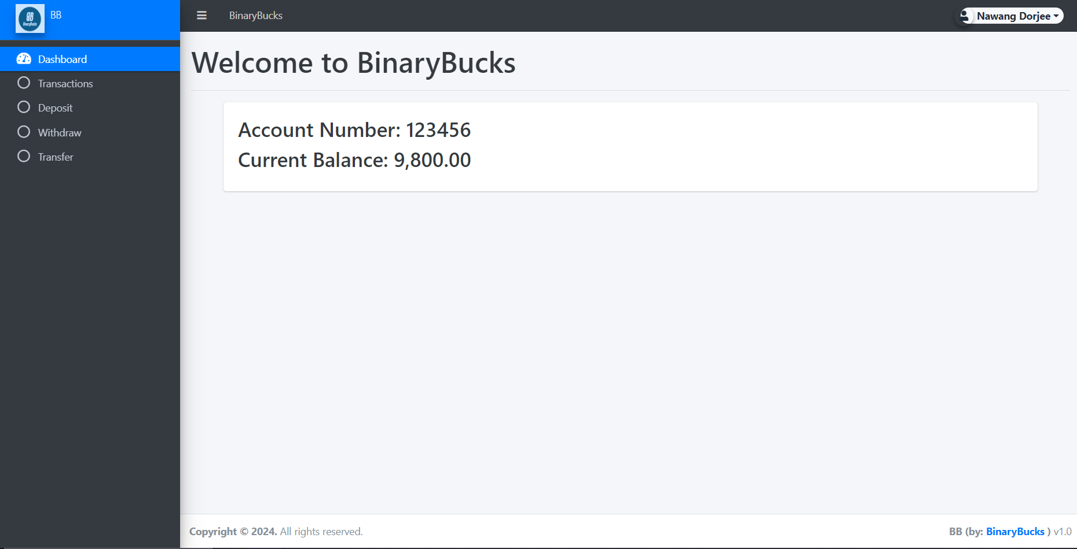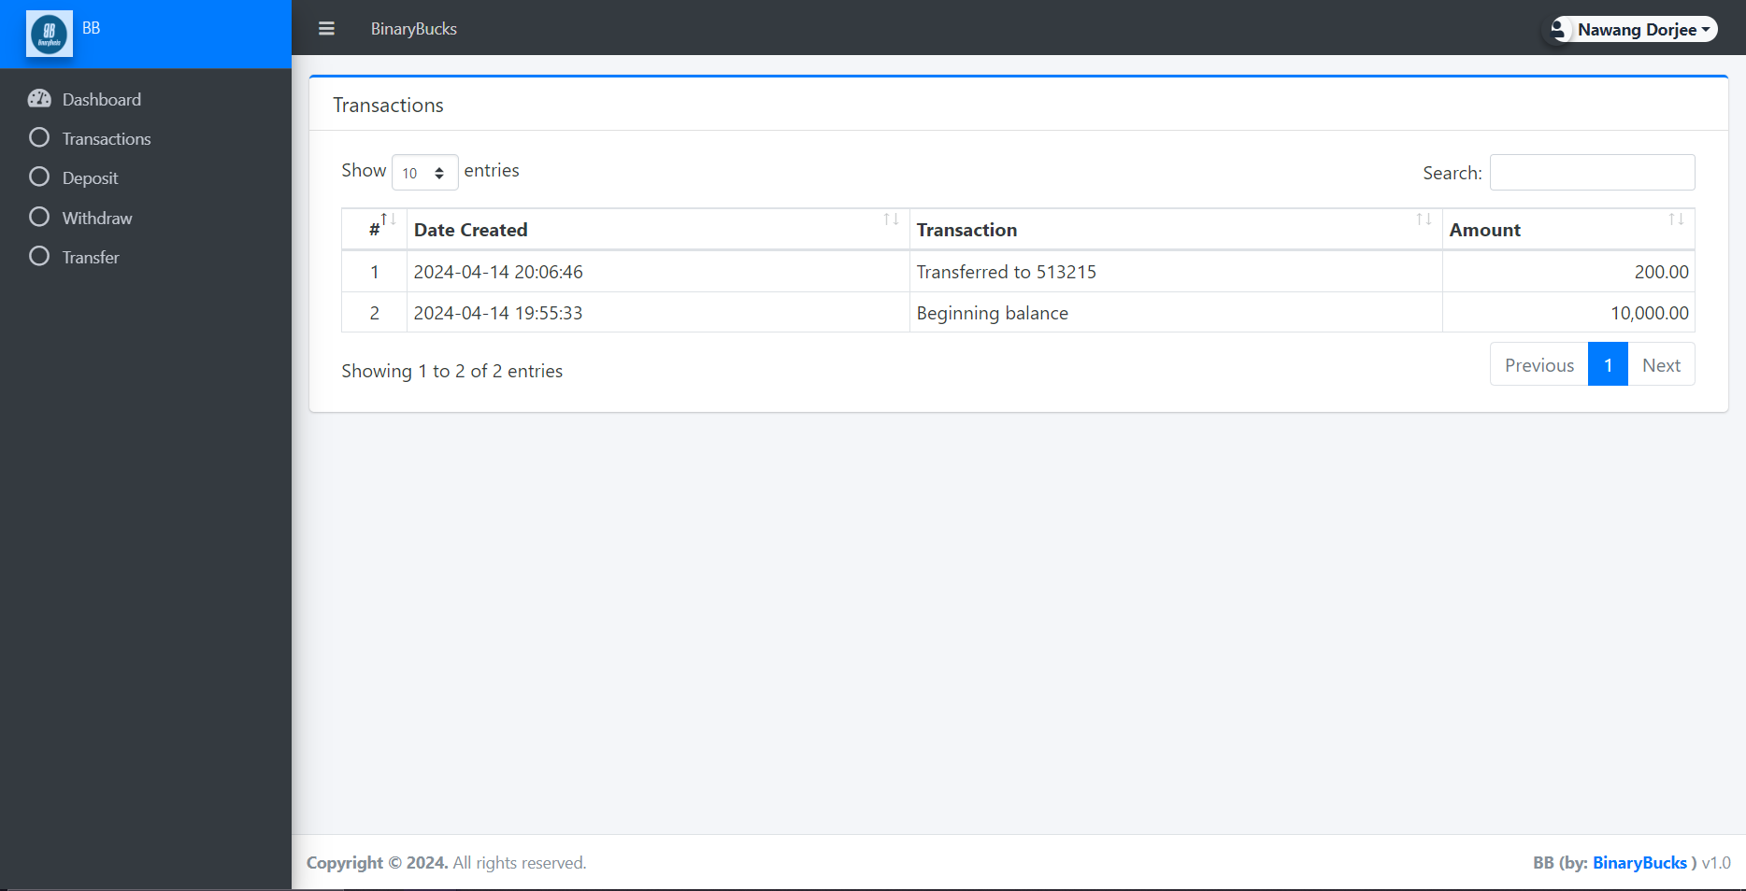

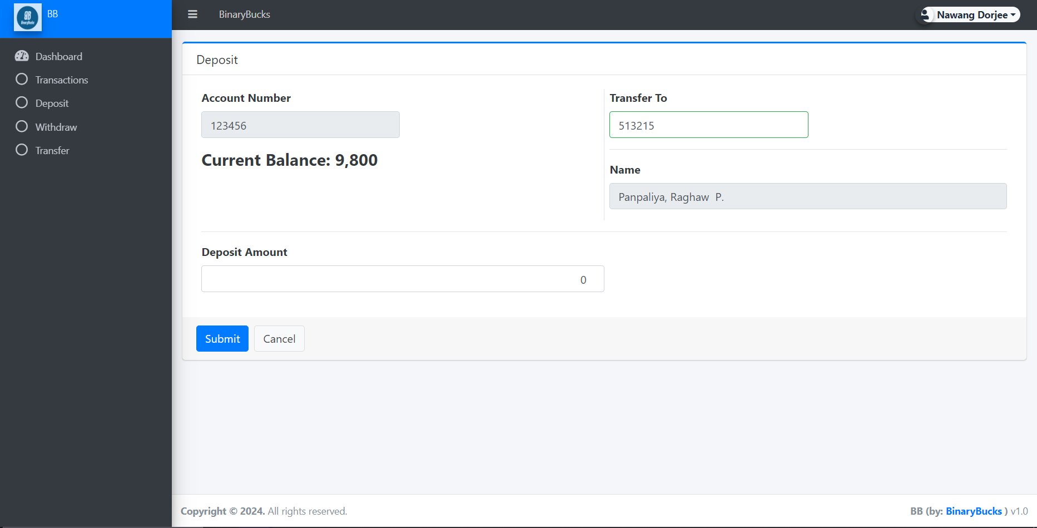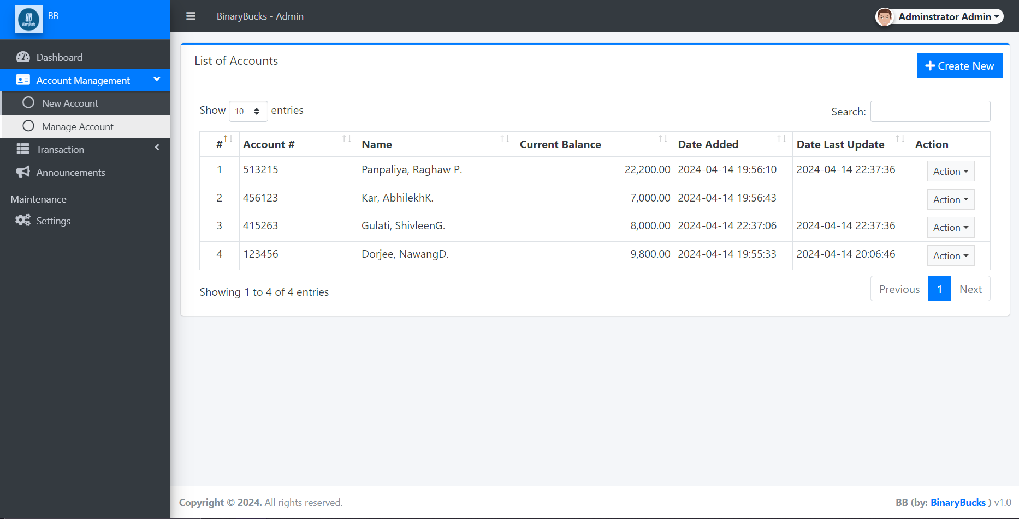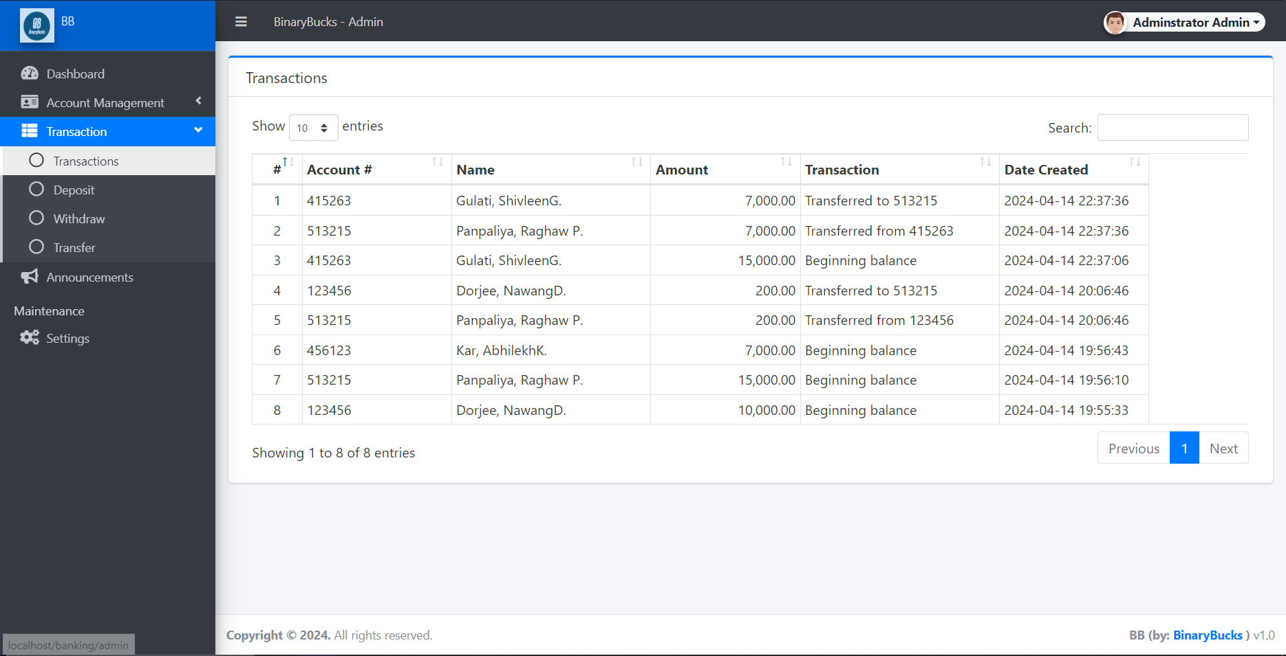

**TESTING**

**5.1 TESTING STRATEGIES**

**5.1.1 UNIT TESTING**

Unit testing involves evaluating individual units or components within a software application to ensure they operate as intended. Developers typically conduct these tests, scrutinizing specific sections of code to confirm each unit functions correctly in isolation. The primary aim is to detect and rectify bugs early in development, ensuring each code unit aligns with its design and behaves as anticipated.

**5.1.2 FUNCTIONAL TESTING**

Functional testing examines a software application's features against predetermined requirements. Unlike unit testing, which focuses on isolated code units, functional testing evaluates the overall system functionality. Test cases are crafted to confirm the application performs its intended functions accurately, meets user needs, and yields expected outcomes across various scenarios. This approach guarantees the software adheres to desired specifications and delivers a dependable user experience.

**5.1.3 INTEGRATION TESTING**

Integration testing concentrates on validating interactions among different modules or components within a software system. It scrutinizes integrated components' interfaces and interactions to ensure they collaborate seamlessly and exchange data accurately. The primary objective is to pinpoint any defects or inconsistencies in the interactions between integrated elements.

**5.2 TEST CASES AND REPORTS**

**5.2.1 UNIT TESTING**

Component Rendering and Layout: We meticulously ensured the accurate rendering of each component by closely comparing the output with the anticipated design. This process involved validating precise element positioning and styling according to design specifications. To ensure responsiveness, we conducted tests across various screen sizes to observe how components adapted. This comprehensive approach allowed us to verify that our application delivered a consistent user experience across diverse devices and viewport sizes.

User Interactions and Event Handling: Our team conducted thorough testing on user interactions, including clicks, inputs, and keyboard events, to ensure that components responded appropriately. For example, we confirmed that clicking a button initiated the intended action and that input fields properly accepted user input. We diligently verified that event handlers were appropriately bound and invoked during user interactions, guaranteeing smooth functionality across our application.

**5.2.2 FUNCTIONAL TESTING**

Testing Backend Endpoints: Our team meticulously scrutinized every backend endpoint to confirm accurate request handling, data processing, and response generation. This process entailed verifying that endpoints appropriately responded to designated HTTP methods and returned the correct status codes for various scenarios. We ensured the backend accurately processed incoming data, encompassing tasks such as parsing request payloads, validating input data, and generating responses with the expected content and format.

CRUD Operation Testing: We conducted thorough testing of CRUD operations (Create, Read, Update, Delete) to validate the proper functionality of each endpoint. This encompassed testing the creation, retrieval, updating, and deletion of entities to confirm that data was managed according to expectations, including storage, retrieval, and manipulation.

**5.3.3 INTEGRATION TESTING**

Frontend-Backend Integration: We conducted meticulous testing on the fusion of frontend and backend components to ensure flawless communication. This encompassed validating the accurate formatting and inclusion of all necessary information in data exchanges between the two. Our team rigorously tested error handling mechanisms to guarantee the frontend adeptly managed various error types returned by the backend, preserving a positive user experience even during error occurrences.

Backend-Database Integration: Thorough testing was carried out to assess the cohesion between the backend application and the database. This entailed confirming the correct processing and persistence of data sent from the backend to the database, as well as ensuring prompt reflection of backend data alterations in the database.

Frontend-Database Integration: We extensively evaluated how frontend components portrayed data retrieved from the database, ensuring precise rendering of backend-fetched data in the front-end UI. Additionally, we verified the accurate reflection of front-end data alterations in the database through back-end interactions.

**CONCLUSION**

In conclusion, the BinaryBucks Banking System represents a significant advancement in the realm of financial technology, poised to revolutionize banking operations. By addressing the shortcomings of traditional systems through centralization, automation, and robust security measures, BinaryBucks aims to elevate both customer experience and administrative efficiency.

With its user-friendly interface and comprehensive functionality, BinaryBucks empowers customers to manage their accounts seamlessly, conduct transactions securely, and access vital financial information with ease. Meanwhile, for bank administrators, the system offers streamlined account management capabilities, real-time transaction monitoring, and the flexibility to adapt user roles and permissions as needed.

By leveraging a combination of frontend and backend technologies, including HTML, CSS, JavaScript, PHP and MySQL, BinaryBucks ensures a responsive, reliable, and scalable platform capable of meeting the evolving needs of modern banking.

In essence, the implementation of BinaryBucks heralds a new era of banking, where efficiency, security, and convenience converge to redefine the banking experience for all stakeholders involved.

**REFERENCES**

[1]<https://github.com/>

[2]<https://git-scm.com/>

[3]<https://chat.openai.com/>

[4]<https://www.youtube.com/>

[5]<https://stackoverflow.com/>